Task Description #2

Use copilot to generate a is_prime() python function.  
  
Prompt given:

  
  
Code:  
  
  
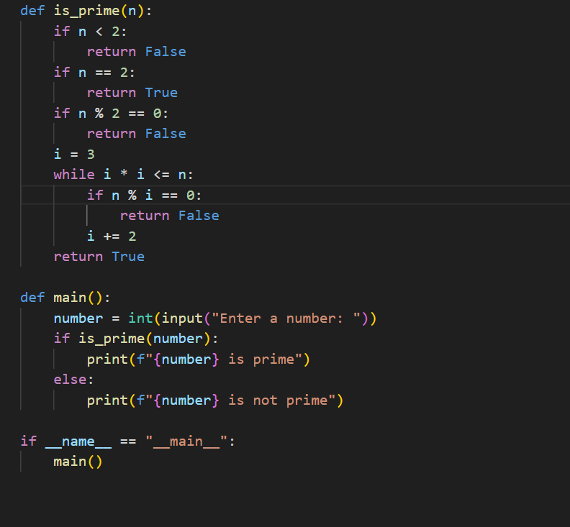

Output:   
  
  
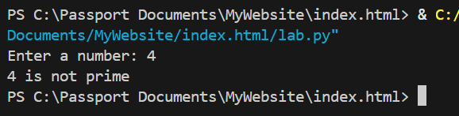  
  
  
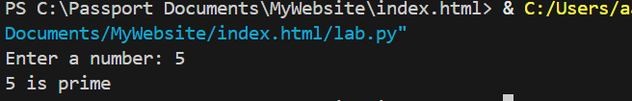  
  
  
  
  
  
  
  
  
  
  
  
  
  
  
  
  
  
  
  
  
  
  
  
  
  
Task Description #3

Write a comment like # function to reverse a string and use copilot to generate the function.  
  
  
  
  
Prompt given to github co pilot:   
  
  
  
Code:   
  
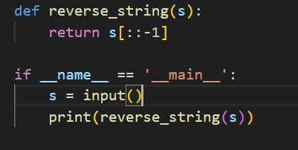  
  
Code Output:   
  
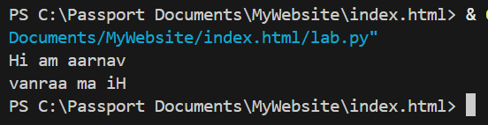



Task Description#4  
  
Generate both recursive and iterative versions of a factorial function using comments.  
  
  
Prompt given to github co pilot:

  
  
  
Code:  
  
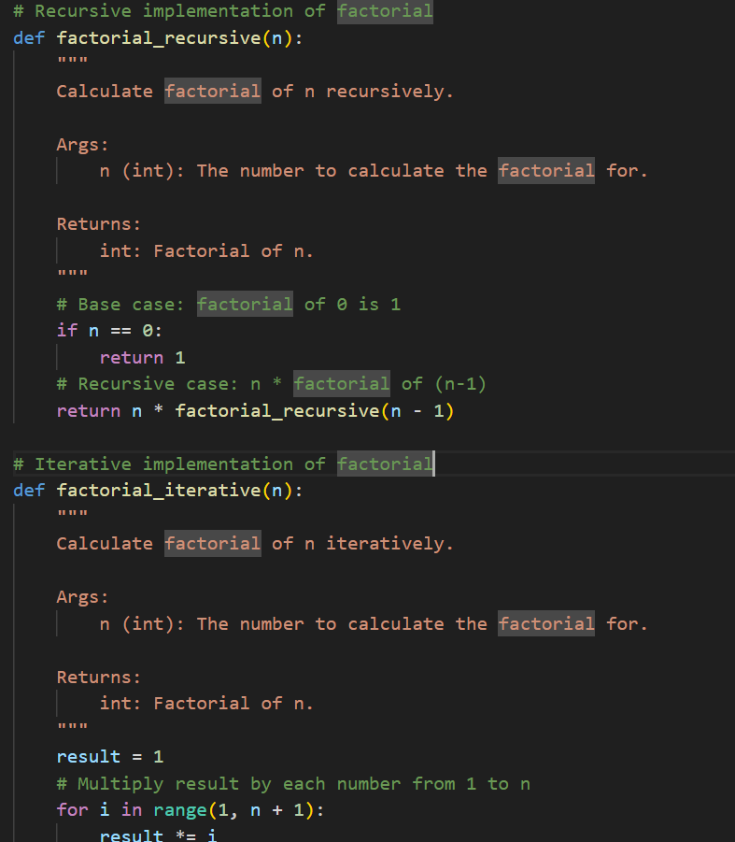 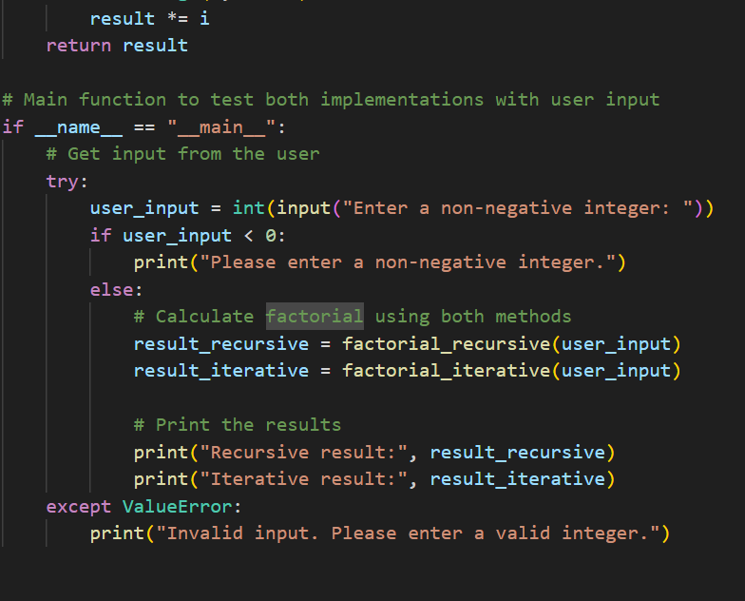  
  
output:  
  
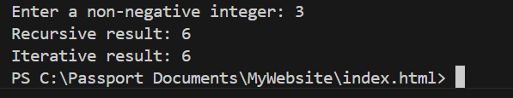  
  
  
  
  
  
  
  
  
Task Description #5  
  
Use co pilot to find the largest number in a ost assess code quality and efficiency  
  
  
Prompt given:  
  
  
  
  
Code:  
  
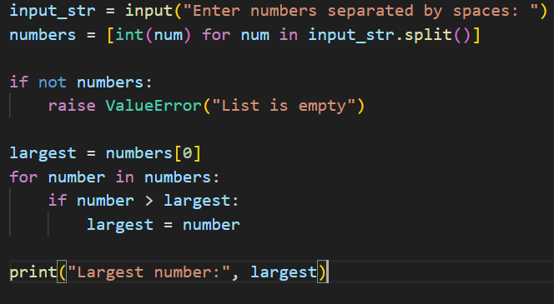  
  
Output:   
  
